**Istanbul Technical University**



**Computer and Informatics Faculty**

**Computer Engineering Department**

**BLG222E COMPUTER ORGANIZATION**

**PROJECT 3: HARDWIRE BASED CONTROL UNIT DESIGN**

**REPORT**

**OF GROUP 3**

Group Members:

150140012 Uğur Uysal

150140031 Pelin Hakverir

150140103 Hüseyin Aküzüm

150140124 Şahin Olut

1. **Introduction**

In this project we designed a hardwire based control unit for our basic computer from the 2nd project. This control unit is able to perform fetch, decode and execution operations for the given instruction list.

### Requirements

1. **Machine Code of the Given Code in Address & Instruction Pairs**

|  |
| --- |
| 0x100 - 0010 1100 0000 0000 - 2C00 |
| 0x101 - 0011 0000 0000 0000 - 3000 |
| 0x102 - 0011 0100 0000 0000 - 3400 |
| 0x103 - 1000 0100 0000 0000 - 8400 |
| 0x104 - 0001 0100 0000 0000 - 1400 |
| 0x105 - 0011 0100 0000 0000 - 3400 |
| 0x106 - 1000 0100 0000 0000 - 8400 |
| 0x107 - 0001 0100 0000 0000 - 1400 |
| 0x108 - 0011 0100 0000 0000 - 3400 |
| 0x109 - 1000 0100 0000 0000 - 8400 |
| 0x10A - 0001 0100 0000 0000 - 1400 |
| 0x10B - 0011 0100 0000 0000 - 3400 |
| 0x10C - 1000 1100 0000 0000 - 8C00 |

1. **Lists of Control Inputs and Corresponding Functions of The Simple Computer**

|  |  |  |
| --- | --- | --- |
| Symbol | Opcode (binary) | Description |
| LDA | 0001 | GPRA←M[EA] |
| LDB | 0010 | GPRB←M[EA] |
| STA | 0011 | M[EA]←GPRA |
| STB | 0100 | M[EA] ←GPRB |
| ADDA | 0101 | AC←AC + GPRA |
| ADDB | 0110 | AC←AC + GPRB |
| BUN | 0111 | PC←EA |
| BZE | 1000 | if Z=1 then PC←EA |
| BNE | 1001 | if N=1 then PC←EA |
| XCH | 1010 | Exchange values in GPRA and GPRB |
| CLRAC | 1011 | AC←0 |
| CLRX | 1100 | X←0 |
| INCX | 1101 | X←X+1 |
| INCB | 1110 | GPRB←GPRB+1 |
| LDSP | 1111 | SP←M[EA] |

1. **Memory State After the Code Execution in Address & Instruction Pairs**

|  |
| --- |
| 0 - 1111 1111 1111 1011 |
| 1 - 0000 0000 0000 0001 |
| 2 - 0000 0000 0000 0011 |
| 3 - 0000 0000 0000 0101 |
| 4 - 0000 0000 0000 0101 |
| 5 - 0000 0000 0000 1001 |
| 6 - 0000 1000 0010 0000 |
| 7 - 1010 1111 0110 1100 |
| 8 - 0000 1111 0011 0000 |

|  |
| --- |
| 0x100 - 0010 1100 0000 0000 - 2C00 |
| 0x101 - 0011 0000 0000 0000 - 3000 |
| 0x102 - 0011 0100 0000 0000 - 3400 |
| 0x103 - 1000 0100 0000 0000 - 8400 |
| 0x104 - 0001 0100 0000 0000 - 1400 |
| 0x105 - 0011 0100 0000 0000 - 3400 |
| 0x106 - 1000 0100 0000 0000 - 8400 |
| 0x107 - 0001 0100 0000 0000 - 1400 |
| 0x108 - 0011 0100 0000 0000 - 3400 |
| 0x109 - 1000 0100 0000 0000 - 8400 |
| 0x10A - 0001 0100 0000 0000 - 1400 |
| 0x10B - 0011 0100 0000 0000 - 3400 |
| 0x10C - 1000 1100 0000 0000 - 8C00 |

1. **Conclusion**

Our control unit’s last view is:

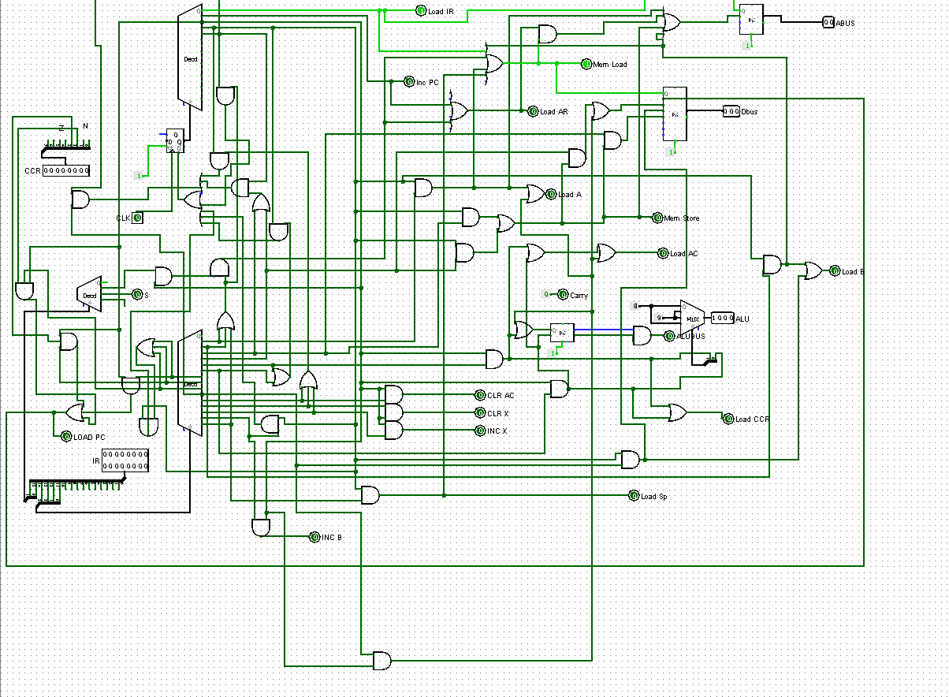

Our basic computer’s last view with the control unit is:

